Overall > no question marks should be shown in empty cells (p.e.: column O)!

**Type R (column A)** > Filter on column C > no empty cells or IM7 allowed!

> Filter on column C > no empty cells or IM7 allowed!

1. Column C should show FIAT. Correct data should be taken from of EMM > Incoming > Call Offs

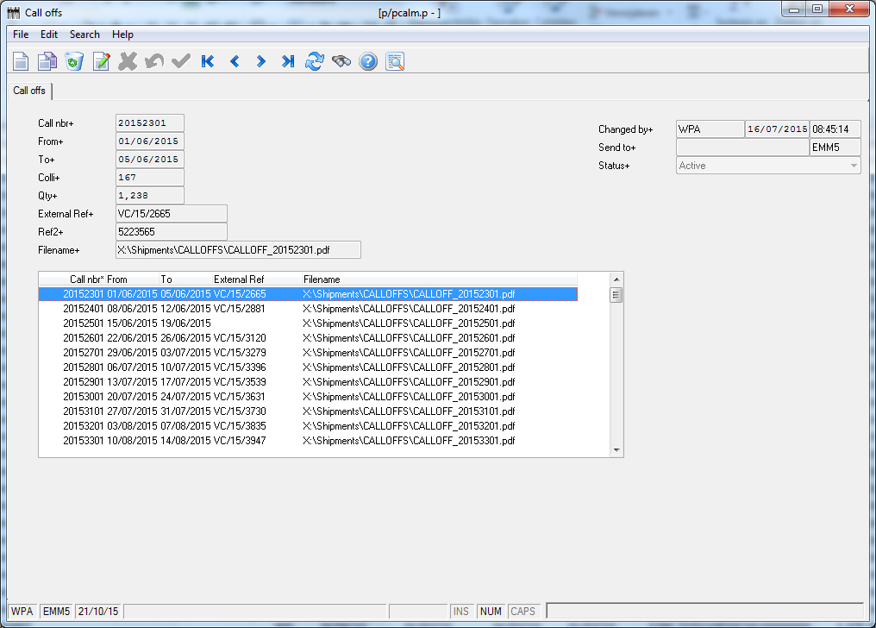

When External Ref is filled than Column C in report should mention FIAT

1. Column D should show External Ref taken from Call Offs as shown here above
2. When column C mentioning FIAT column D should always be filled. Data taken from Call Offs as shown here above
3. When Status (column E) is 900 column C, D, always must mention FIAT and External Ref as mentioned here above and all date columns must be filled

**Type F (column A)**

F > status 400 + 500 > OutEntrepot must be empty > When InEntrepot is filled then InAV and OutAV and Entrepot always should be filled

F > Status 500 > column H, I, P should always be filled

F > status 800 > always all columns with dates must be filled.

F > status 800 > If OutEntrepot is empty than OutEntrepot must be equal to Ex-EMS date

F > status 800 > when column N is filled then column P must always mention EXIT

F > status 800 > when column Q mention IMA then column R must be ART546-…..-..

**Type S (column A)**

S > when status 200 > No Out Entrepot date must be filled

S > when status 250 > No Out Entrepot date must be filled

S > when status 250 > OutAV must be filled always

S > when status 250 > ENTREPOT must always be filled

S > when status 500 > OutAV must always be filled

S > when status 900 > column F, G, H, I, P must be filled always